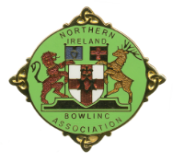
Northern Ireland Bowling Association (NIBA)

Code of Conduct for Junior Members

Young people are expected to:

- Behave and listen to all instructions from the team manager.
- Respect officials and accept decisions.
- Show respect to other junior members/leaders and show team spirit.
- Respect opponents.
- Show appropriate loyalty and be gracious in winning or defeat.
- Not cheat or be violent/aggressive.
- Keep themselves safe at all times.
- Not get involved in inappropriate peer pressure and push others into something they do not want to do.
- Refrain from the use of bad language or racial/sectarian references.
- Avoid bullying or making offensive remarks (including inappropriate use/abuse of social media or networking websites and mobile technology).
- Not consume alcohol (under 18 years).
- Not be involved in inappropriate behaviour.
- Refrain from taking illegal drugs or be involved with the use of illegal substances/activities.

NIBA reserves the right to discipline anyone who is in breach of this Code of Conduct.

I agree to abide by the above code of conduct:

Signed participant: ……………………………....
Parent/Guardian: ………………………….…….
Date: ………………………………………………

